**Acknowledgment**

I would like to extend my sincere gratitude to CSism Technologies for providing me with the opportunity to intern with your esteemed organization. During my internship, I had the invaluable experience of working with CSS3, HTML5, JavaScript, and PHP also SQL.

The knowledge and skills I have acquired in front-end and back-end development have significantly enhanced my understanding of web technologies. The practical experience gained through real-world projects has been instrumental in solidifying my theoretical knowledge and improving my problem-solving abilities.

I am especially thankful to my mentor, Mr. Rohit Solanki and the entire development team for their guidance, support, and encouragement. Their insights and constructive feedback have greatly contributed to my professional growth.

This internship has been a crucial step in my career development, and I am deeply appreciative of the chance to contribute to and learn from such a dynamic and innovative environment.

Lastly, I would also like to express my appreciation to CSism Technologies for the invaluable experience and support throughout my internship. The knowledge and experience gained at CSism Technologies have significantly contributed to my professional growth and understanding of web technologies.

**Abstract**

This report details my 12-week internship at CSISM Technologies, a prominent tech company dedicated to enhancing programming education for students and Software developing company. Under the guidance of CEO Mr. Ashutosh Gahiwal and MENTOR Mr Rohit Solanki, I engaged in a comprehensive learning experience focusing on HTML5, CSS3, JS, SQL and PHP. The internship provided me with hands-on exposure to web development, allowing me to deepen my technical skills and gain a thorough understanding of modern web technologies. The experience also helped me develop my communication and mentoring abilities. This report reflects on the skills acquired, the challenges faced, and the significant impact of CSISM Technologies' innovative educational approach on my professional growth.

**Introduction**

**Company Overview:**

The company CSism Technologies began as a freelance venture while its founders completed college .

In 2012, The business officially launched, starting as an institute offering coaching classes.

The institute evolved into a full-fledged software development company.

Technologies Used: HTML, CSS, JavaScript, SQL, & PHP

Founder: Mr. Ashutosh Ghaiwal  
Mentor for Internship: Mr. Rohit Solanki

Tagline of Company : “We server with Smile”



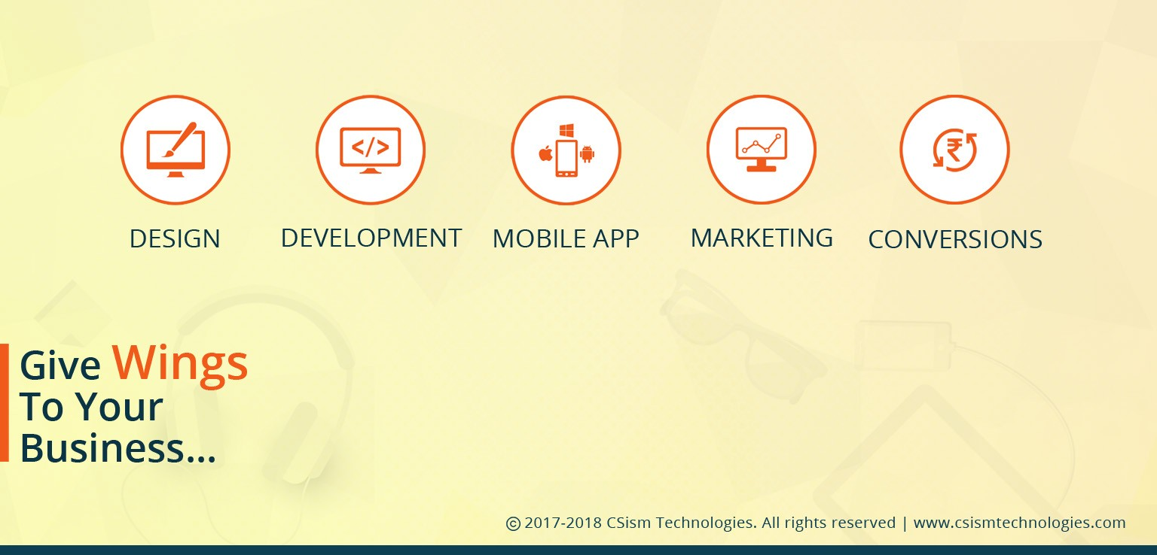

**Internship Work**

**Timeline Summary:**

During my twelve-week internship, I developed a professional, retail-oriented website for the official Amul outlet, named Amul Shopee. The project began with focusing on the foundational web development technologies such as HTML and CSS and progressively advanced to integrating responsive designs via Bootstrap, adding interactivity with animations, and building backend functionality using PHP with database integration. The site presented Amul's product lineup, facilitated customer inquiries, and provided essential store information. This hands-on project gave me crucial exposure to real-world business requirements, professional web development workflows, and technical problem-solving.

**Week 01 Introduction to HTML**

* Learned basic HTML syntax and common tags.
* Continued exploring different HTML elements and attributes.
* Practiced creating simple web pages with structured content for the Amul outlet.
* Explored additional tags and completed a mini HTML project.
* Reviewed HTML basics in preparation for CSS learning.

**Week 02 Getting Started with CSS**

* Started CSS fundamentals: linking CSS files and styling HTML elements.
* Learned selectors, properties, and values.
* Practiced styling various web page components like text, backgrounds, and margins.
* Worked with CSS Flexbox for better layout management.
* Completed a project styling a webpage and reviewed CSS concepts.

**Week 03 Forms and Responsive Design with HTML & CSS**

* Created and styled a registration/inquiry form for the outlet.
* Implemented HTML5 form validation for improved user input.
* Enhanced form aesthetics using CSS.
* Tested form responsiveness across devices.
* Finalized form project and collected peer feedback.

**Week 04 Bootstrap Framework Introduction**

* Applied Bootstrap components to prototype the Amul Shopee site.
* Explored the Bootstrap grid system for responsive layouts.
* Integrated navigation bars and footers in the project.
* Customized Bootstrap components to fit Amul branding.
* Completed the initial site layout and prepared for next steps.

**Week 05 Advanced Bootstrap Usage**

* Deepened understanding of Bootstrap structure and utility classes.
* Used Bootstrap responsive features for spacing and alignment.
* Enhanced website appearance using advanced Bootstrap functions.
* Finalized page layout and design refinement based on peer feedback.

**Week 06 Animations and User Interactivity**

* Learned and implemented Bootstrap animations and carousel transitions.
* Customized animations to complement the site theme without distraction.
* Tested animations performance and usability.
* Prepared the website for final presentation and peer review.

**Week 07 PHP Integration & Responsive Enhancements**

* Explored deeper Bootstrap concepts related to responsiveness.
* Created an index page and added a responsive slider using Bootstrap carousel.
* Optimized the slider for mobile devices.
* Designed an About page using Bootstrap components.
* Peer-reviewed PHP components to ensure functioning consistency.

**Week 08 Main Sections Development in PHP**

* Developed core homepage elements including Header, Hero Section, and Services.
* Created Portfolio and Testimonials sections.
* Built Contact Section with call-to-action elements.
* Finalized page footer and started website functionality testing.

**Week 09 Website Finalization and Reviews**

* Conducted comprehensive reviews of the website for design and functionality.
* Fixed inconsistencies, especially those affecting mobile responsiveness.
* Documented all formatting and updates within the project.
* Incorporated mentor feedback and completed peer reviews.
* Self-studied project presentation techniques for effective delivery.

**Week 10 Database Connectivity and Admin Panel**

* Connected web pages to the database to enable dynamic content management.
* Developed an admin panel for managing website content and products.
* Added backup, restore, and full data recovery options.
* Reviewed database linkage and ensured secure, efficient performance.

**Week 11 User Experience Improvements and Secondary Project**

* Added dynamic “Enquire” buttons that autofill inquiry forms.
* Implemented “Read More” expandable content options in the admin panel.
* Developed a modern slider and UI animations for a supplementary project related to a dressing company.
* Conducted peer review for UI polish and consistency.

**Week 12 Final Testing and Project Submission**

* Utilized Apax to smooth overall site loading speed.
* Performed detailed final testing and debugging of all projects.
* Ensured consistency and quality across all developed materials.
* Delivered formal presentations and submited the entire project for evaluation.
* Reflected on the learning experience and potential areas for improvement.

The internship experience enabled me to develop a fully functional, branded Amul outlet website with integrated frontend and backend systems over a structured 12-week timeline. I gained proficiency in HTML, CSS, Bootstrap, PHP, and SQL database management, applied real-world UI/UX principles, and managed project feedback cycles effectively. This hands-on exposure significantly advanced my technical skills, professional discipline, and confidence to handle similar complex projects in the future.

Throughout this 12-week internship, I transitioned from mastering the basics of HTML and CSS to developing full-featured, responsive web applications using Bootstrap and PHP, with SQL-driven data management. I gained hands-on experience in both frontend and backend processes, UI/UX improvement, teamwork, and professional project delivery. The mentorship and iterative feedback I received continuously propelled my understanding and motivation. This internship significantly broadened my practical web development abilities and enthusiasm for tackling complex real-world projects.

**Project**

After completing my 12-week internship, I was ready to apply my newly acquired knowledge and skills.

**Project**: The project was to develop a basic **shop website** using **HTML, JS, CSS** (Frontend languages) and **SQL, PHP** (Backend languages).

I have successfully built a basic **shop website** for *Shree Laxmi Amul Shopiee* by gaining full knowledge of each and every part of website development. The site was designed to be neither too simple nor too advanced — just enough to cover the core features needed for a small business. In the future, this foundation can be used to build a more advanced version.

It had features like:

1. **Advanced Database Management**: Admin can edit and delete contact enquiries directly from the frontend instead of the backend.
2. **Owl Carousel**: A smooth image slider that enhances the look and feel of the website.
3. **Bootstrap**: Makes the site responsive and easy to access on any browser or device.
4. **Contact and Enquiry Form**: Allows customers to submit enquiries directly through the website without needing to call.  
   **And many more…**

**Tools Used**

1.**Notepad:**

HTML, CSS, and JavaScript Development: Used Notepad as an initial tool for writing and editing HTML, CSS, and JavaScript code. It provided a straightforward environment for coding and testing basic functionality.

**2. Visual Studio Code (VSCode):**

Enhanced Coding Experience: Transitioned to Visual Studio Code for a more robust development environment. Utilized features such as syntax highlighting, code suggestions, and extensions to improve productivity and code quality.

Employed VSCode’s integrated tools for color coding and text formatting, which significantly streamlined the development process and improved code readability.

**3. Browser:**

Testing and Debugging: Used web browsers (such as Chrome, Firefox) for real-time testing and debugging of web pages. Leveraged browser developer tools to inspect elements, test responsiveness, and troubleshoot issues.

**4 XAMPP Server:**

Local Server Environment- Implemented XAMPP as a local server environment to run and test PHP scripts and manage MySQL databases. This setup facilitated the development of dynamic web applications and the integration of server-side functionalities.

**Development Steps**

**Project Inception and Planning:**

• Defined the project’s objective: to develop a basic and informative website for Shree Laxmi Amul Shopiee, aimed at showcasing shop details and allowing customer enquiries.  
• Outlined the scope of the website including shop introduction, image sliders, contact form, and enquiry handling.  
• Identified the target users as local customers seeking information about shop products, timings, and location.

**Design and Development:**

• Designed the database schema to store user enquiry details submitted through the contact form.  
• Used Visual Studio Code to design and develop the website frontend using HTML, CSS, and JavaScript.  
• Utilized XAMPP Server for backend development, including PHP scripting and MySQL database integration.

**Feature Implementation:**

• Applied responsive design techniques using CSS and Bootstrap to ensure compatibility across devices.  
• Designed a clean and user-friendly interface with form validations using HTML and JavaScript.  
• Integrated Owl Carousel for image sliders to visually enhance the homepage.

**Testing and Deployment:**

• Conducted cross-browser testing to ensure consistent performance and appearance.  
• Used browser developer tools to debug layout issues and optimizeresponsiveness.  
• Ran the website locally using XAMPP (localhost environment), suitable for offline presentation and future deployment readiness.

**The website was successfully hosted on ByteHost using a free hosting plan.**

**A custom domain name was linked to ensure public accessibility and smoother user experience.**

**CODE**

**Index.php (Home page HTML,CSS,JAVA)**

<?php

// Check if device is mobile for optimized content delivery

function isMobile() {

    return preg_match("/(android|avantgo|blackberry|bolt|boost|cricket|docomo|fone|hiptop|mini|mobi|palm|phone|pie|tablet|up\.browser|up\.link|webos|wos)/i",

        $_SERVER['HTTP_USER_AGENT']);

}

$isMobile = isMobile();

?>

<!DOCTYPE html>

<html lang="en">

<head>

    <meta charset="UTF-8">

    <meta name="viewport" content="width=device-width, initial-scale=1.0, maximum-scale=5.0">

    <title>Amul - Home</title>

    <!-- Mobile-specific meta tags -->

    <meta name="theme-color" content="#0a4da3">

    <meta name="apple-mobile-web-app-capable" content="yes">

    <meta name="apple-mobile-web-app-status-bar-style" content="black">

    <meta name="format-detection" content="telephone=no">

    <!-- Performance optimization -->

    <link rel="preconnect" href="https://cdn.jsdelivr.net">

    <link rel="dns-prefetch" href="https://cdn.jsdelivr.net">

    <!-- Preloading critical resources -->

    <link rel="preload" href="https://cdn.jsdelivr.net/npm/bootstrap@5.3.2/dist/css/bootstrap.min.css" as="style">

    <link rel="preload" href="<?php echo $isMobile ? 'images/Ice Cream Collection-mobile.jpg' : 'images/Ice Cream Collection.jpg'; ?>" as="image">

    <link rel="preload" href="css/common.css" as="style">

    <!-- Bootstrap CSS -->

    <link href="https://cdn.jsdelivr.net/npm/bootstrap@5.3.2/dist/css/bootstrap.min.css" rel="stylesheet">

    <!-- Bootstrap Icons -->

    <link rel="stylesheet" href="https://cdn.jsdelivr.net/npm/bootstrap-icons@1.11.1/font/bootstrap-icons.css">

    <!-- Animate.css (with reduced payload for mobile) -->

    <?php if ($isMobile): ?>

    <link rel="stylesheet" href="https://cdnjs.cloudflare.com/ajax/libs/animate.css/4.1.1/animate.min.css">

    <?php else: ?>

    <link rel="stylesheet" href="https://cdnjs.cloudflare.com/ajax/libs/animate.css/4.1.1/animate.min.css">

    <?php endif; ?>

    <!-- Core CSS files -->

    <link rel="stylesheet" href="css/common.css">

    <link rel="stylesheet" href="css/layouts/header-footer.css">

    <!-- Page-specific styling -->

    <link rel="stylesheet" href="css/pages/index.css">

    <!-- Mobile optimization CSS -->

    <link rel="stylesheet" href="css/mobile-fixes.css">

    <!-- InfinityFree compatibility fixes -->

    <link rel="stylesheet" href="css/compatibility/infinity-compatibility.css">

    <!-- Animation fixes to ensure colors and animations work -->

    <link rel="stylesheet" href="css/animation-fixes.css">

    <!-- AOS Animation Library (loaded for all devices) -->

    <link rel="stylesheet" href="https://unpkg.com/aos@next/dist/aos.css" />

</head>

<body>

<?php include 'header.php'; ?>

<div class="floating-background">

    <!-- Ice cream elements will be generated by JavaScript -->

</div>

<!-- SECTION 1: HERO - Ultra-Modern Premium Carousel Slider (Fixed) -->

<div class="premium-slider-container mt-3 mb-4">

  <div id="amulCarousel" class="carousel slide premium-carousel" data-bs-ride="carousel">

    <!-- Carousel Progress Bar -->

    <div class="carousel-progress">

      <div class="carousel-progress-bar"></div>

    </div>

    <!-- 3D Carousel Inner -->

    <div class="carousel-inner premium-inner">

      <!-- Slide 1 -->

      <div class="carousel-item active" data-slide-id="1">

        <div class="premium-slide-wrapper">

          <div class="carousel-image-container">

            <img src="images/Ice Cream Collection.jpg" alt="Ice Cream Collection" onerror="this.src='Amul.jpg';">

            <div class="slide-particles" id="particles-1"></div>

            <div class="image-reflections"></div>

          </div>

          <div class="premium-caption">

            <div class="caption-badge">Featured</div>

            <h2 class="slide-title">Delicious<br><span class="highlight">Ice Creams</span></h2>

            <div class="caption-divider"><span></span></div>

            <p class="slide-description">Explore our premium collection of rich, creamy Amul ice creams in various flavors.</p>

            <a href="products.php" class="btn btn-slider">

              <span class="btn-text">Discover Now</span>

              <span class="btn-icon"><i class="bi bi-arrow-right"></i></span>

            </a>

            <div class="slide-number">01</div>

          </div>

        </div>

      </div>

      <!-- Slide 2 -->

      <div class="carousel-item" data-slide-id="2">

        <div class="premium-slide-wrapper">

          <div class="carousel-image-container">

            <img src="images/Dairy Products.jpg" alt="Dairy Products" onerror="this.src='Amul.jpg';">

            <div class="slide-particles" id="particles-2"></div>

            <div class="image-reflections"></div>

          </div>

          <div class="premium-caption">

            <div class="caption-badge">Popular</div>

            <h2 class="slide-title">Fresh<br><span class="highlight">Dairy Products</span></h2>

            <div class="caption-divider"><span></span></div>

            <p class="slide-description">Premium quality butter, cheese and milk products for your daily needs.</p>

            <a href="products.php" class="btn btn-slider">

              <span class="btn-text">Explore Range</span>

              <span class="btn-icon"><i class="bi bi-arrow-right"></i></span>

            </a>

            <div class="slide-number">02</div>

          </div>

        </div>

      </div>

      <!-- Slide 3 -->

      <div class="carousel-item" data-slide-id="3">

        <div class="premium-slide-wrapper">

          <div class="carousel-image-container">

            <img src="images/Refreshing Beverages.jpg" alt="Refreshing Beverages" onerror="this.src='Amul.jpg';">

            <div class="slide-particles" id="particles-3"></div>

            <div class="image-reflections"></div>

          </div>

          <div class="premium-caption">

            <div class="caption-badge">New</div>

            <h2 class="slide-title">Refreshing<br><span class="highlight">Beverages</span></h2>

            <div class="caption-divider"><span></span></div>

            <p class="slide-description">Cool down with Amul's refreshing drink collection for hot summer days.</p>

            <a href="products.php" class="btn btn-slider">

              <span class="btn-text">Try Now</span>

              <span class="btn-icon"><i class="bi bi-arrow-right"></i></span>

            </a>

            <div class="slide-number">03</div>

          </div>

        </div>

      </div>

    </div>

    <!-- Modern Neumorphic Navigation Buttons -->

   <div class="testimonial-controls">

                        <button class="carousel-control-prev testimonial-control" type="button" data-bs-target="#amulCarousel" data-bs-slide="prev">

                            <i class="bi bi-chevron-left"></i>

                        </button>

                        <button class="carousel-control-next testimonial-control" type="button" data-bs-target="#amulCarousel" data-bs-slide="next">

                            <i class="bi bi-chevron-right"></i>

                        </button>

                    </div>

  </div>

</div>

<!-- SECTION 2: ABOUT US -->

<main class="container py-4">

    <div class="row justify-content-center">

        <div class="col-lg-10">

            <!-- Hero Section -->

            <div class="content-card mb-5" data-aos="fade-up" data-aos-duration="1000">

                <div class="text-center mb-4">

                    <h1 class="animate__animated animate__fadeInDown"><i class="bi bi-cart3"></i> Shree Laxmi Amul Shopiee</h1>

                    <p class="badge bg-danger fs-6 animate__animated animate__fadeIn animate__delay-1s">Official Amul Outlet</p>

                </div>

                <div class="row align-items-center">

                    <div class="col-md-6" data-aos="fade-right" data-aos-delay="200">

                        <h2 class="text-primary"><i class="bi bi-cheese"></i> Welcome to Shree Laxmi Amul Shopiee</h2>

                        <p class="lead">Your One-Stop Destination for Fresh & Authentic Amul Products!</p>

                        <p>We are proud to be an official Amul outlet, bringing you the freshest dairy delights, tasty treats, and daily essentials—straight from the house of Amul.</p>

                        <p>Whether you're picking up your favorite butter, sipping on refreshing Amul Kool, or enjoying a scoop of rich Amul ice cream, we've got everything you love—under one roof.</p>

                        <div class="mt-4">

                            <a href="about.php" class="btn btn-primary btn-lg ripple-btn animate__animated animate__pulse animate__infinite">

                                <i class="bi bi-info-circle me-2"></i> Learn More About Us

                            </a>

                        </div>

                    </div>

                    <div class="col-md-6" data-aos="fade-left" data-aos-delay="400">

                        <div class="text-center">

                            <img src="images/iceindex.webp" alt="Amul Products" class="img-fluid rounded shadow-sm" style="max-height: 300px;">

                        </div>

                    </div>

                </div>

            </div>

            <!-- SECTION 3: SERVICES / WHAT WE OFFER -->

            <div class="content-card mb-5 what-we-offer-section" data-aos="fade-up" data-aos-duration="1000">

    <div class="amul-theme-background"></div>

    <h2 class="text-center mb-4 position-relative"><i class="bi bi-cup-hot"></i> What We Offer</h2>

    <div class="row row-cols-1 row-cols-md-2 g-4">

        <div class="col" data-aos="zoom-in-up" data-aos-delay="100">

            <div class="card h-100 border-0 shadow-lg service-card service-card-blue">

                <div class="card-body text-center">

                    <div class="icon-box icon-box-blue mb-4">

                        <i class="bi bi-droplet-fill"></i>

                    </div>

                    <h5 class="card-title text-primary">Amul Milk & Dairy Products</h5>

                    <p class="card-text">Fresh milk, curd, and other dairy essentials for your daily needs.</p>

                </div>

                <div class="card-animation-element"></div>

            </div>

        </div>

        <div class="col" data-aos="zoom-in-up" data-aos-delay="200">

            <div class="card h-100 border-0 shadow-lg service-card service-card-red">

                <div class="card-body text-center">

                    <div class="icon-box icon-box-red mb-4">

                        <i class="bi bi-snow2"></i>

                    </div>

                    <h5 class="card-title text-danger">Ice Creams & Desserts</h5>

                    <p class="card-text">Delicious ice creams and frozen desserts in various flavors.</p>

                </div>

                <div class="card-animation-element"></div>

            </div>

        </div>

        <div class="col" data-aos="zoom-in-up" data-aos-delay="300">

            <div class="card h-100 border-0 shadow-lg service-card service-card-orange">

                <div class="card-body text-center">

                    <div class="icon-box icon-box-orange mb-4">

                        <i class="bi bi-cup-straw"></i>

                    </div>

                    <h5 class="card-title text-warning">Chocolates & Beverages</h5>

                    <p class="card-text">Tasty chocolates and refreshing beverages for all ages.</p>

                </div>

                <div class="card-animation-element"></div>

            </div>

        </div>

        <div class="col" data-aos="zoom-in-up" data-aos-delay="400">

            <div class="card h-100 border-0 shadow-lg service-card service-card-green">

                <div class="card-body text-center">

                    <div class="icon-box icon-box-green mb-4">

                        <i class="bi bi-egg-fried"></i>

                    </div>

                    <h5 class="card-title text-success">Paneer, Cheese, Butter & More</h5>

                    <p class="card-text">Wide range of dairy products for your cooking needs.</p>

                </div>

                <div class="card-animation-element"></div>

            </div>

        </div>

    </div>

    <div class="text-center mt-4" data-aos="zoom-in" data-aos-delay="500">

        <div class="alert alert-info alert-amul" role="alert">

            <div class="alert-icon"><i class="bi bi-info-circle-fill"></i></div>

            <div class="alert-text">Wholesale & Retail Options Available</div>

        </div>

    </div>

</div>

            <!-- SECTION 4: WHY CHOOSE US -->

            <div class="content-card mb-5 benefits-section" data-aos="fade-up" data-aos-duration="1000">

                <h2 class="text-center mb-5"><i class="bi bi-bell"></i> Why Choose Us?</h2>

                <div class="row">

                    <div class="col-md-6 mb-4" data-aos="fade-right" data-aos-delay="100">

                        <div class="benefit-card d-flex align-items-center">

                            <div class="flex-shrink-0">

                                <div class="benefit-icon">

                                    <i class="bi bi-patch-check"></i>

                                </div>

                            </div>

                            <div class="flex-grow-1 ms-3">

                                <h5>100% Genuine Amul Products</h5>

                                <p class="mb-0">Authorized Amul outlet with authentic products</p>

                            </div>

                        </div>

                    </div>

                    <div class="col-md-6 mb-4" data-aos="fade-left" data-aos-delay="200">

                        <div class="benefit-card d-flex align-items-center">

                            <div class="flex-shrink-0">

                                <div class="benefit-icon">

                                    <i class="bi bi-tag"></i>

                                </div>

                            </div>

                            <div class="flex-grow-1 ms-3">

                                <h5>Best Prices Guaranteed</h5>

                                <p class="mb-0">Competitive pricing for all our products</p>

                            </div>

                        </div>

                    </div>

                    <div class="col-md-6 mb-4" data-aos="fade-right" data-aos-delay="300">

                        <div class="benefit-card d-flex align-items-center">

                            <div class="flex-shrink-0">

                                <div class="benefit-icon">

                                    <i class="bi bi-people"></i>

                                </div>

                            </div>

                            <div class="flex-grow-1 ms-3">

                                <h5>Friendly & Quick Service</h5>

                                <p class="mb-0">Courteous staff ready to assist you</p>

                            </div>

                        </div>

                    </div>

                    <div class="col-md-6 mb-4" data-aos="fade-left" data-aos-delay="400">

                        <div class="benefit-card d-flex align-items-center">

                            <div class="flex-shrink-0">

                                <div class="benefit-icon">

                                    <i class="bi bi-stars"></i>

                                </div>

                            </div>

                            <div class="flex-grow-1 ms-3">

                                <h5>Clean, Hygienic Store Environment</h5>

                                <p class="mb-0">Maintaining highest standards of cleanliness</p>

                            </div>

                        </div>

                    </div>

                </div>

            </div>

            <!-- SECTION 5: PRODUCTS HIGHLIGHTS -->

            <div class="content-card mb-5 products-highlight" data-aos="fade-up" data-aos-duration="1200">

                <h2 class="text-center mb-4"><i class="bi bi-basket"></i> Featured Products</h2>

                <p class="text-center mb-5">Discover our most popular Amul products loved by customers</p>

                <div class="row row-cols-2 row-cols-md-4 g-4">

                    <div class="col" data-aos="flip-left" data-aos-delay="100">

                        <div class="product-thumbnail">

                            <div class="product-img-wrapper">

                                <img src="images/Tricone.jpg" alt="Amul Tricone" class="img-fluid rounded product-img">

                                <div class="product-overlay">

                                    <a href="products.php" class="btn btn-sm btn-light">View Details</a>

                                </div>

                            </div>

                            <div class="product-badge"><span>Popular</span></div>

                            <h5 class="mt-2 text-center">Amul Tricone</h5>

                        </div>

                    </div>

                    <div class="col" data-aos="flip-left" data-aos-delay="200">

                        <div class="product-thumbnail">

                            <div class="product-img-wrapper">

                                <img src="images/Amul Butter.jpg" alt="Amul Butter" class="img-fluid rounded product-img">

                                <div class="product-overlay">

                                    <a href="products.php" class="btn btn-sm btn-light">View Details</a>

                                </div>

                            </div>

                            <div class="product-badge"><span>Classic</span></div>

                            <h5 class="mt-2 text-center">Amul Butter</h5>

                        </div>

                    </div>

                    <div class="col" data-aos="flip-left" data-aos-delay="300">

                        <div class="product-thumbnail">

                            <div class="product-img-wrapper">

                                <img src="images/Amul Taaza Milk.jpg" alt="Amul Taaza Milk" class="img-fluid rounded product-img">

                                <div class="product-overlay">

                                    <a href="products.php" class="btn btn-sm btn-light">View Details</a>

                                </div>

                            </div>

                            <div class="product-badge"><span>Essential</span></div>

                            <h5 class="mt-2 text-center">Amul Taaza Milk</h5>

                        </div>

                    </div>

                    <div class="col" data-aos="flip-left" data-aos-delay="400">

                        <div class="product-thumbnail">

                            <div class="product-img-wrapper">

                                <img src="images/Mango Lassi.jpg" alt="Mango Lassi" class="img-fluid rounded product-img">

                                <div class="product-overlay">

                                    <a href="products.php" class="btn btn-sm btn-light">View Details</a>

                                </div>

                            </div>

                            <div class="product-badge"><span>Refreshing</span></div>

                            <h5 class="mt-2 text-center">Mango Lassi</h5>

                        </div>

                    </div>

                </div>

                <div class="text-center mt-4" data-aos="zoom-in" data-aos-delay="500">

                    <a href="products.php" class="btn btn-outline-primary btn-lg animated-button">

                        <span class="button-text"><i class="bi bi-grid me-2"></i> View All Products</span>

                        <span class="button-animation"></span>

                    </a>

                </div>

            </div>

            <!-- SECTION 6: TESTIMONIALS -->

            <div class="content-card mb-5 testimonials-section" data-aos="fade-up" data-aos-duration="1200">

                <h2 class="text-center mb-5"><i class="bi bi-chat-quote"></i> What Our Customers Say</h2>

                <div id="testimonialCarousel" class="carousel slide" data-bs-ride="carousel">

                    <div class="carousel-inner">

                        <div class="carousel-item active">

                            <div class="testimonial-card">

                                <div class="testimonial-rating">

                                    <i class="bi bi-star-fill"></i>

                                    <i class="bi bi-star-fill"></i>

                                    <i class="bi bi-star-fill"></i>

                                    <i class="bi bi-star-fill"></i>

                                    <i class="bi bi-star-fill"></i>

                                </div>

                                <p class="testimonial-text">"I've been shopping at Shree Laxmi Amul Shopiee for years. The quality of their products is consistently excellent, and the staff is always helpful and friendly. The best place to get Amul products in Pachmarg!"</p>

                                <div class="testimonial-author">

                                    <div class="testimonial-avatar">

                                        <i class="bi bi-person-circle"></i>

                                    </div>

                                    <h5>Suresh Patel</h5>

                                </div>

                            </div>

                        </div>

                        <div class="carousel-item">

                            <div class="testimonial-card">

                                <div class="testimonial-rating">

                                    <i class="bi bi-star-fill"></i>

                                    <i class="bi bi-star-fill"></i>

                                    <i class="bi bi-star-fill"></i>

                                    <i class="bi bi-star-fill"></i>

                                    <i class="bi bi-star-half"></i>

                                </div>

                                <p class="testimonial-text">"Their ice cream selection is amazing! My kids love visiting the shop after school. The prices are fair and the store is always clean and well-maintained. Highly recommended!"</p>

                                <div class="testimonial-author">

                                    <div class="testimonial-avatar">

                                        <i class="bi bi-person-circle"></i>

                                    </div>

                                    <h5>Priya Sharma</h5>

                                </div>

                            </div>

                        </div>

                        <div class="carousel-item">

                            <div class="testimonial-card">

                                <div class="testimonial-rating">

                                    <i class="bi bi-star-fill"></i>

                                    <i class="bi bi-star-fill"></i>

                                    <i class="bi bi-star-fill"></i>

                                    <i class="bi bi-star-fill"></i>

                                    <i class="bi bi-star-fill"></i>

                                </div>

                                <p class="testimonial-text">"As a restaurant owner, I depend on Shree Laxmi Amul Shopiee for bulk supplies of cheese and butter. Their wholesale prices are competitive and delivery is always on time. Great business partner!"</p>

                                <div class="testimonial-author">

                                    <div class="testimonial-avatar">

                                        <i class="bi bi-person-circle"></i>

                                    </div>

                                    <h5>Raj Malhotra</h5>

                                </div>

                            </div>

                        </div>

                    </div>

                    <div class="testimonial-controls">

                        <button class="carousel-control-prev testimonial-control" type="button" data-bs-target="#testimonialCarousel" data-bs-slide="prev">

                            <i class="bi bi-chevron-left"></i>

                        </button>

                        <button class="carousel-control-next testimonial-control" type="button" data-bs-target="#testimonialCarousel" data-bs-slide="next">

                            <i class="bi bi-chevron-right"></i>

                        </button>

                    </div>

                </div>

            </div>

            <!-- SECTION 7: VISIT US -->

            <div class="content-card mb-5 location-section" data-aos="fade-up" data-aos-duration="1000">

                <h2 class="text-center mb-4"><i class="bi bi-geo-alt"></i> Visit Us Today!</h2>

                <div class="row justify-content-center">

                    <div class="col-md-6" data-aos="fade-right" data-aos-delay="200">

                        <div class="map-container">

                            <iframe src="https://www.google.com/maps/embed?pb=!1m18!1m12!1m3!1d3760.227876302633!2d72.85!3d19.55!2m3!1f0!2f0!3f0!3m2!1i1024!2i768!4f13.1!3m3!1m2!1s0x0%3A0x0!2zMTnCsDMwJzAwLjAiTiA3MsKwNTAnMjQuMCJF!5e0!3m2!1sen!2sin!4v1620112345678!5m2!1sen!2sin" width="100%" height="300" style="border:0;" allowfullscreen="" loading="lazy"></iframe>

                        </div>

                    </div>

                    <div class="col-md-6" data-aos="fade-left" data-aos-delay="300">

                        <div class="card border-0 bg-light h-100">

                            <div class="card-body">

                                <ul class="list-group list-group-flush">

                                    <li class="list-group-item bg-transparent location-item">

                                        <i class="bi bi-geo-alt-fill text-danger"></i> <strong>Location:</strong> Shree Laxmi Amul Shopiee, [Pachmarg]

                                    </li>

                                    <li class="list-group-item bg-transparent location-item">

                                        <i class="bi bi-clock-fill text-danger"></i> <strong>Timing:</strong> Open Daily – 7:00 AM to 11:00 PM

                                    </li>

                                    <li class="list-group-item bg-transparent location-item">

                                        <i class="bi bi-telephone-fill text-danger"></i> <strong>Contact:</strong> +91 9890377098

                                    </li>

                                </ul>

                                <div class="text-center mt-3">

                                    <a href="https://maps.app.goo.gl/pG3D8cZ4Udd39mgs9" target="_blank" class="btn btn-danger pulsate-btn">

                                        <i class="bi bi-map me-2"></i> Get Directions

                                    </a>

                                </div>

                            </div>

                        </div>

                    </div>

                </div>

            </div>

            <!-- SECTION 8: CALL TO ACTION -->

            <div class="content-card mb-5 cta-section" data-aos="fade-up" data-aos-duration="1000">

                <div class="text-center py-4">

                    <h2 class="text-danger mb-4" data-aos="zoom-in" data-aos-delay="100"><i class="bi bi-heart"></i> Thank You for Trusting Shree Laxmi Amul Shopiee!</h2>

                    <p class="fst-italic mb-4" data-aos="fade-up" data-aos-delay="200">"Amul – The Taste of India, Now at Your Neighborhood Store."</p>

                    <div class="mt-4 d-flex justify-content-center flex-wrap gap-3">

                        <a href="contact.php" class="btn btn-lg cta-button" data-aos="flip-up" data-aos-delay="300">

                            <span><i class="bi bi-headset me-2"></i> Contact Us Today</span>

                        </a>

                    </div>

                </div>

            </div>

        </div>

    </div>

</main>

<?php include 'footer.php'; ?>

<!-- Bootstrap JS Bundle with Popper -->

<script src="https://cdn.jsdelivr.net/npm/bootstrap@5.3.2/dist/js/bootstrap.bundle.min.js"></script>

<!-- InfinityFree compatibility fixes -->

<script src="infinity-fixes.js"></script>

<!-- AOS Animation Library (always loaded) -->

<script src="https://unpkg.com/aos@next/dist/aos.js"></script>

<!-- Ice Cream Background Animation -->

<script src="js/icecream-bg.js"></script>

<!-- Animation fixes script -->

<script src="animations.js"></script>

<!-- Additional page-specific animations -->

<script>

document.addEventListener('DOMContentLoaded', function() {

    // Initialize all animations via our animation script

    // Extra animations for this page

    document.querySelectorAll('.product-thumbnail').forEach(product => {

        product.addEventListener('mouseenter', function() {

            this.classList.add('animate__animated', 'animate__pulse');

        });

        product.addEventListener('mouseleave', function() {

            this.classList.remove('animate__animated', 'animate__pulse');

        });

    });

    // Enable all animations that might be disabled

    document.querySelectorAll('.animate__animated').forEach(el => {

        // Make sure animations aren't disabled

        el.style.animationDuration = '';

        el.style.animationDelay = '';

    });

    // Initialize AOS with more dynamic settings

    if (typeof AOS !== 'undefined') {

        AOS.init({

            duration: 800,

            easing: 'ease-in-out',

            once: false,

            mirror: false

        });

        // Refresh AOS when scrolling to catch any missed animations

        window.addEventListener('scroll', function() {

            AOS.refresh();

        }, {passive: true});

    }

});

</script>

<!-- IntersectionObserver for lazy loading and animation -->

<script>

document.addEventListener('DOMContentLoaded', function() {

    // Use IntersectionObserver for lazy loading and animations

    if ('IntersectionObserver' in window) {

        // Lazy load images

        const lazyImages = document.querySelectorAll('img[loading="lazy"]');

        const imageObserver = new IntersectionObserver((entries) => {

            entries.forEach(entry => {

                if (entry.isIntersecting) {

                    const image = entry.target;

                    if (image.dataset.src) {

                        image.src = image.dataset.src;

                        image.removeAttribute('data-src');

                    }

                    image.classList.add('loaded');

                    imageObserver.unobserve(image);

                }

            });

        });

        lazyImages.forEach(img => imageObserver.observe(img));

        // Animate elements when they scroll into view

        <?php if (!$isMobile): ?>

        const animatedElems = document.querySelectorAll('.animate-on-scroll');

        const animationObserver = new IntersectionObserver((entries) => {

            entries.forEach(entry => {

                if (entry.isIntersecting) {

                    entry.target.classList.add('visible');

                    animationObserver.unobserve(entry.target);

                }

            });

        });

        animatedElems.forEach(elem => animationObserver.observe(elem));

        <?php else: ?>

        // Just show elements immediately on mobile for better performance

        document.querySelectorAll('.animate-on-scroll').forEach(el => {

            el.classList.add('visible');

        });

        <?php endif; ?>

    }

});

</script>

</body>

</html>

**Header.php**

<?php

$currentPage = basename($_SERVER['PHP_SELF']);

// Set page-specific metadata

$pageTitle = "Shree Laxmi Amul Shopiee";

$pageDescription = "Official Amul products outlet in Pachmarg offering fresh dairy products, ice creams, and more.";

switch($currentPage) {

    case 'index.php':

        $pageTitle = "Shree Laxmi Amul Shopiee - Official Store";

        $pageDescription = "Your neighborhood store for fresh and authentic Amul products. Ice creams, dairy, beverages and more.";

        break;

    case 'products.php':

        $pageTitle = "Our Products - Shree Laxmi Amul Shopiee";

        $pageDescription = "Explore our wide range of Amul products including ice creams, butter, cheese, milk and beverages.";

        break;

    case 'about.php':

        $pageTitle = "About Us - Shree Laxmi Amul Shopiee";

        $pageDescription = "Learn about our journey and commitment to quality Amul products since 2014.";

        break;

    case 'gallery.php':

        $pageTitle = "Gallery - Shree Laxmi Amul Shopiee";

        $pageDescription = "Take a visual tour of our store, products, and FSSAI certification.";

        break;

    case 'contact.php':

        $pageTitle = "Contact Us - Shree Laxmi Amul Shopiee";

        $pageDescription = "Get in touch with us. Find our location, hours and contact information.";

        break;

    case 'enquiry.php':

        $pageTitle = "Product Enquiry - Shree Laxmi Amul Shopiee";

        $pageDescription = "Ask about product availability, pricing, or place bulk orders.";

        break;

}

?>

<!DOCTYPE html>

<html lang="en">

<head>

    <meta charset="UTF-8" />

    <meta name="viewport" content="width=device-width, initial-scale=1.0, maximum-scale=5.0" />

    <title><?php echo $pageTitle; ?></title>

    <meta name="description" content="<?php echo $pageDescription; ?>" />

    <!-- CSS Links -->

    <!-- Bootstrap CSS -->

    <link href="https://cdn.jsdelivr.net/npm/bootstrap@5.3.2/dist/css/bootstrap.min.css" rel="stylesheet">

    <link rel="stylesheet" href="https://cdn.jsdelivr.net/npm/bootstrap-icons@1.11.1/font/bootstrap-icons.css" />

    <!-- Animate.css for animations -->

    <link rel="stylesheet" href="https://cdnjs.cloudflare.com/ajax/libs/animate.css/4.1.1/animate.min.css" />

    <!-- Core CSS files -->

    <link rel="stylesheet" href="css/common.css" />

    <link rel="stylesheet" href="css/layouts/header-footer.css" />

    <!-- Page-specific CSS determined by current page -->

    <?php

    $cssFile = pathinfo($currentPage, PATHINFO_FILENAME);

    if(file_exists("css/pages/{$cssFile}.css")) {

        echo "<link rel=\"stylesheet\" href=\"css/pages/{$cssFile}.css\" />";

    }

    ?>

    <!-- Mobile optimization CSS -->

    <link rel="stylesheet" href="css/mobile-fixes.css" />

    <!-- Animation fixes to ensure colors and animations work -->

    <link rel="stylesheet" href="css/animation-fixes.css" />

    <!-- Color fixes CSS - new file -->

    <link rel="stylesheet" href="css/color-fixes.css" />

    <!-- AOS Animation Library -->

    <link rel="stylesheet" href="https://unpkg.com/aos@next/dist/aos.css" />

    <!-- Custom Inline Styles for Header -->

    <style>

        .navbar {

            background: linear-gradient(to right, #0a4da3, #1665c1);

            padding: 0.8rem 0;

        }

        .logo-img {

            height: 50px;

            width: auto;

            margin-right: 10px;

        }

        .navbar-brand {

            display: flex;

            align-items: center;

            gap: 10px;

            color: white;

            font-weight: bold;

            font-size: 1.25rem;

            white-space: nowrap;

        }

        .shop-name {

            color: white;

            font-size: 1.2rem;

            text-shadow: 1px 1px 2px rgba(0,0,0,0.2);

        }

        @media (max-width: 767.98px) {

            .logo-img {

                height: 40px;

            }

            .shop-name {

                font-size: 1rem;

                max-width: 160px;

                line-height: 1.2;

                white-space: normal;

            }

        }

    </style>

</head>

<body>

<!-- Navbar -->

<nav class="navbar navbar-expand-lg navbar-dark sticky-top">

    <div class="container">

        <a class="navbar-brand" href="index.php">

            <img src="Amul.jpg" alt="Amul Logo" class="logo-img" />

            <span class="shop-name">Shree Laxmi Amul Shopiee</span>

        </a>

        <button class="navbar-toggler" type="button" data-bs-toggle="collapse" data-bs-target="#navbarNav">

            <span class="navbar-toggler-icon"></span>

        </button>

        <div class="collapse navbar-collapse" id="navbarNav">

            <ul class="navbar-nav ms-auto">

                <li class="nav-item"><a class="nav-link <?php echo ($currentPage == 'index.php') ? 'active' : ''; ?>" href="index.php">Home</a></li>

                <li class="nav-item"><a class="nav-link <?php echo ($currentPage == 'about.php') ? 'active' : ''; ?>" href="about.php">About</a></li>

                <li class="nav-item"><a class="nav-link <?php echo ($currentPage == 'products.php') ? 'active' : ''; ?>" href="products.php">Products</a></li>

                <li class="nav-item"><a class="nav-link <?php echo ($currentPage == 'gallery.php') ? 'active' : ''; ?>" href="gallery.php">Gallery</a></li>

                <li class="nav-item"><a class="nav-link <?php echo ($currentPage == 'contact.php') ? 'active' : ''; ?>" href="contact.php">Contact</a></li>

                <li class="nav-item"><a class="nav-link <?php echo ($currentPage == 'enquiry.php') ? 'active' : ''; ?>" href="enquiry.php">Enquiry</a></li>

            </ul>

        </div>

    </div>

</nav>

<!-- Optional JS for Bootstrap -->

<script src="https://cdn.jsdelivr.net/npm/bootstrap@5.3.2/dist/js/bootstrap.bundle.min.js"></script>

<main id="main-content">

**Database connection Code**

**db.php**

<?php

// Database configuration

class Database {

    // Database credentials

    private $host = "sql308.ByteHost33.com";

    private $db = "b33_39246376_amul";  // Using lowercase to match server configuration

    private $user = "b33_39246376";

    private $pass = "OM@om123";

    private $conn = null;

    // Method to get connection

    public function connect() {

        try {

            // Set error mode

            mysqli_report(MYSQLI_REPORT_ERROR | MYSQLI_REPORT_STRICT);

            // Create connection

            $this->conn = new mysqli($this->host, $this->user, $this->pass, $this->db);

            // Check connection

            if ($this->conn->connect_error) {

                throw new Exception("Database connection failed: " . $this->conn->connect_error);

            }

            // Set charset

            $this->conn->set_charset("utf8");

            return $this->conn;

        } catch (Exception $e) {

            // Log error but don't terminate script

            $this->logError($e->getMessage());

            // Return null instead of dying - allows page to still render

            return null;

        }

    }

    // Add method to log errors

    private function logError($message) {

        // Simple error logging - append to error log file

        $logFile = __DIR__ . '/db_errors.log';

        $timestamp = date('Y-m-d H:i:s');

        $logMessage = "[$timestamp] $message\n";

        error_log($logMessage, 3, $logFile);

    }

}

// Create a global connection variable that can be used by other scripts

$database = new Database();

$conn = $database->connect();

// If connection failed, you can add additional handling here

if ($conn === null) {

    // Log this major error - could redirect to an error page if needed

    error_log("Critical database connection error in " . $_SERVER['SCRIPT_NAME']);

}

?>

**About.php**

<!DOCTYPE html>

<html lang="en">

<head>

    <meta charset="UTF-8">

    <meta name="viewport" content="width=device-width, initial-scale=1.0, maximum-scale=5.0">

    <meta name="theme-color" content="#0a4da3">

    <meta name="apple-mobile-web-app-capable" content="yes">

    <meta name="apple-mobile-web-app-status-bar-style" content="black">

    <meta name="format-detection" content="telephone=no">

    <title>Amul - About Us</title>

    <!-- Performance optimization -->

    <link rel="preconnect" href="https://cdn.jsdelivr.net">

    <link rel="dns-prefetch" href="https://cdn.jsdelivr.net">

    <!-- Preload critical assets -->

    <link rel="preload" href="https://cdn.jsdelivr.net/npm/bootstrap@5.3.2/dist/css/bootstrap.min.css" as="style">

    <link rel="preload" href="style.css" as="style">

    <link rel="preload" href="mobile-fixes.css" as="style">

      <!-- Bootstrap CSS -->

    <link href="https://cdn.jsdelivr.net/npm/bootstrap@5.3.2/dist/css/bootstrap.min.css" rel="stylesheet">

    <!-- Bootstrap Icons -->

    <link rel="stylesheet" href="https://cdn.jsdelivr.net/npm/bootstrap-icons@1.11.1/font/bootstrap-icons.css">

    <!-- Animate.css (with reduced set for mobile) -->

    <link rel="stylesheet" href="https://cdnjs.cloudflare.com/ajax/libs/animate.css/4.1.1/animate.min.css">

    <!-- Site-specific styling -->

    <link rel="stylesheet" href="style.css">

    <!-- Mobile optimization CSS -->

    <link rel="stylesheet" href="mobile-fixes.css">

    <!-- InfinityFree compatibility fixes -->

    <link rel="stylesheet" href="infinity-compatibility.css">

    <!-- Inline critical CSS for faster rendering -->

    <style>

        /* Critical CSS for initial render */

        body {margin:0; padding:0; font-family:system-ui,-apple-system,"Segoe UI",Roboto,sans-serif;}

        .content-card {background:#fff; border-radius:10px; box-shadow:0 5px 15px rgba(0,0,0,0.08); padding:2rem;}

        @media (max-width:767.98px) {.content-card{padding:1.25rem;}}

    </style>

</head>

<body>

<?php include 'header.php'; ?>

<div class="floating-background">

    <!-- Ice cream elements will be generated by JavaScript -->

</div>

<main class="container py-5" id="main-content">

    <div class="row justify-content-center">

        <div class="col-lg-10">

            <div class="content-card animate__animated animate__fadeIn">

                <h1 class="text-center mb-4 animate__animated animate__fadeInDown">About Us</h1>

                <!-- About Us Section -->

                <section class="mb-5 animate__animated animate__fadeIn animate__delay-1s">

                    <div class="row align-items-center">

                        <!-- Increase size and add animation for store-front.jpg -->

                        <div class="col-md-5 mb-4 mb-md-0">

                            <!-- Make store-front.jpg bigger and add extra animations -->

                            <img src="images/store-front.jpg"

                                 alt="Shree Laxmi Amul Shopiee Store Front"

                                 class="img-fluid rounded shadow animate__animated animate__zoomIn animate__pulse animate__slower"

                                 style="width:100%; max-width:600px; height:auto;"

                                 onerror="this.src='Amul.jpg';">

                        </div>

                        <div class="col-md-7">

                            <h2 class="border-start border-4 border-primary ps-3 mb-4">Our Story</h2>

                            <p>Welcome to Shree Laxmi Amul Shopiee, your trusted neighborhood store for all things Amul. Established in 2014, we have been serving our community with fresh, high-quality Amul products that bring joy and nutrition to families across Pachmarg and surrounding areas.</p>

                            <p>As an authorized Amul outlet, we take pride in delivering the authentic taste of India's most beloved dairy brand directly to our customers. Our journey began with a simple mission: to ensure that every household has easy access to fresh Amul products at fair prices.</p>

                        </div>

                    </div>

                </section>

                <!-- Features Section -->

                <section class="mb-5 animate__animated animate__fadeIn animate__delay-2s">

                    <h2 class="text-center mb-4">Features</h2>

                    <div class="row row-cols-1 row-cols-md-3 g-4">

                        <div class="col">

                            <div class="card h-100 border-0 shadow-sm">

                                <div class="card-body text-center">

                                    <div class="feature-icon bg-primary bg-gradient text-white rounded-circle mb-3 mx-auto">

                                        <i class="bi bi-shop"></i>

                                    </div>

                                    <h5 class="card-title">Official Amul Outlet</h5>

                                    <p class="card-text">Authorized by GCMMF to sell genuine Amul products with quality assurance.</p>

                                </div>

                            </div>

                        </div>

                        <div class="col">

                            <div class="card h-100 border-0 shadow-sm">

                                <div class="card-body text-center">

                                    <div class="feature-icon bg-danger bg-gradient text-white rounded-circle mb-3 mx-auto">

                                        <i class="bi bi-star"></i>

                                    </div>

                                    <h5 class="card-title">Premium Quality</h5>

                                    <p class="card-text">Fresh products maintained in proper storage conditions to preserve quality.</p>

                                </div>

                            </div>

                        </div>

                        <div class="col">

                            <div class="card h-100 border-0 shadow-sm">

                                <div class="card-body text-center">

                                    <div class="feature-icon bg-success bg-gradient text-white rounded-circle mb-3 mx-auto">

                                        <i class="bi bi-clock-history"></i>

                                    </div>

                                    <h5 class="card-title">Extended Hours</h5>

                                    <p class="card-text">Open daily from 7:00 AM to 11:00 PM for your convenience.</p>

                                </div>

                            </div>

                        </div>

                    </div>

                </section>

                <!-- Services Section -->

                <section class="mb-5 animate__animated animate__fadeIn animate__delay-2s">

                    <h2 class="text-center mb-4">Services</h2>

                    <div class="row align-items-center">

                        <div class="col-md-6 order-md-2 mb-4 mb-md-0">

                            <!-- Increase size and add animation for service.jpg -->

                            <img src="images/service.jpg"

                                 alt="Our Services"

                                 class="img-fluid rounded shadow animate__animated animate__zoomIn animate__shakeX animate__delay-1s"

                                 style="width:100%; max-width:600px; height:auto;"

                                 onerror="this.src='Amul.jpg';">

                        </div>

                        <div class="col-md-6 order-md-1">

                            <div class="accordion" id="servicesAccordion">

                                <div class="accordion-item">

                                    <h3 class="accordion-header">

                                        <button class="accordion-button" type="button" data-bs-toggle="collapse" data-bs-target="#collapseOne">

                                            <i class="bi bi-basket me-2"></i> Retail Sales

                                        </button>

                                    </h3>

                                    <div id="collapseOne" class="accordion-collapse collapse show" data-bs-parent="#servicesAccordion">

                                        <div class="accordion-body">

                                            We offer a complete range of Amul products for individual customers with competitive pricing.

                                        </div>

                                    </div>

                                </div>

                                <div class="accordion-item">

                                    <h3 class="accordion-header">

                                        <button class="accordion-button collapsed" type="button" data-bs-toggle="collapse" data-bs-target="#collapseTwo">

                                            <i class="bi bi-boxes me-2"></i> Wholesale Supply

                                        </button>

                                    </h3>

                                    <div id="collapseTwo" class="accordion-collapse collapse" data-bs-parent="#servicesAccordion">

                                        <div class="accordion-body">

                                            Special pricing and delivery arrangements for bulk orders to small businesses and event organizers.

                                        </div>

                                    </div>

                                </div>

                                <div class="accordion-item">

                                    <h3 class="accordion-header">

                                        <button class="accordion-button collapsed" type="button" data-bs-toggle="collapse" data-bs-target="#collapseFour">

                                            <i class="bi bi-calendar-event me-2"></i> Special Orders

                                        </button>

                                    </h3>

                                    <div id="collapseFour" class="accordion-collapse collapse" data-bs-parent="#servicesAccordion">

                                        <div class="accordion-body">

                                            We take special orders for ice cream cakes and bulk products for events with advance notice.

                                        </div>

                                    </div>

                                </div>

                                <div class="accordion-item">

                                    <h3 class="accordion-header">

                                        <button class="accordion-button collapsed" type="button" data-bs-toggle="collapse" data-bs-target="#collapseThree">

                                            <i class="bi bi-clock-history me-2"></i> Extended Hours

                                        </button>

                                    </h3>

                                    <div id="collapseThree" class="accordion-collapse collapse" data-bs-parent="#servicesAccordion">

                                        <div class="accordion-body">

                                            Open daily from 7:00 AM to 11:00 PM for your convenience.

                                        </div>

                                    </div>

                                </div>

                            </div>

                        </div>

                    </div>

                </section>

                <!-- Who We Are Section -->

                <section class="mb-5 animate__animated animate__fadeIn animate__delay-3s">

                    <div class="bg-light p-4 rounded shadow-sm who-we-are-section">

                        <h2 class="text-center mb-4">Who We Are</h2>

                        <div class="row">

                            <div class="col-md-8 offset-md-2">

                                <p class="lead text-center">We are a family-owned business committed to providing the best of Amul to our community since 2014. Quality, service, and customer satisfaction are at the heart of everything we do.</p>

                                <div class="mission-statement text-center p-3 mb-4 rounded bg-white shadow-sm">

                                    <h4 class="text-primary"><i class="bi bi-bullseye"></i> Our Mission</h4>

                                    <p class="mb-0">To deliver fresh, authentic Amul products while fostering a sense of community and trust among our valued customers.</p>

                                </div>

                                <div class="d-flex align-items-start mb-4">

                                    <div class="flex-shrink-0">

                                        <span class="badge rounded-circle bg-primary p-3"><i class="bi bi-people-fill fs-5"></i></span>

                                    </div>

                                    <div class="flex-grow-1 ms-3">

                                        <h5>Family Values</h5>

                                        <p class="text-muted">We pride ourselves on maintaining a warm, welcoming environment that feels like home.</p>

                                    </div>

                                </div>

                                <div class="d-flex align-items-start mb-4">

                                    <div class="flex-shrink-0">

                                        <span class="badge rounded-circle bg-primary p-3"><i class="bi bi-heart-fill fs-5"></i></span>

                                    </div>

                                    <div class="flex-grow-1 ms-3">

                                        <h5>Community Care</h5>

                                        <p class="text-muted">Strengthening local ties by offering friendly service and participating in neighborhood events.</p>

                                    </div>

                                </div>

                                <div class="d-flex align-items-start mb-4">

                                    <div class="flex-shrink-0">

                                        <span class="badge rounded-circle bg-primary p-3"><i class="bi bi-award-fill fs-5"></i></span>

                                    </div>

                                    <div class="flex-grow-1 ms-3">

                                        <h5>Quality First</h5>

                                        <p class="text-muted">Strict standards to ensure only the freshest products reach your table.</p>

                                    </div>

                                </div>

                            </div>

                        </div>

                        <!-- Owner & Co-Owner Section -->

                        <div class="row text-center mt-5">

                            <div class="col-md-6">

                                <!-- Owner image made bigger and animated -->

                                <img src="images/papa.jpg"

                                     alt="Owner"

                                     class="img-fluid rounded-circle shadow mb-3 animate__animated animate__zoomIn animate__pulse animate__slower"

                                     style="width:200px; height:200px; object-fit:cover;"

                                     onerror="this.src='Amul.jpg';">

                                <h5 class="mt-2">Mr. Pradip Patil</h5>

                                <p class="text-muted">Owner</p>

                            </div>

                            <div class="col-md-6">

                                <!-- Co-Owner image made bigger and animated -->

                                <img src="images/om.jpg"

                                     alt="Co-Owner"

                                     class="img-fluid rounded-circle shadow mb-3 animate__animated animate__zoomIn animate__rubberBand animate__delay-2s"

                                     style="width:200px; height:200px; object-fit:cover;"

                                     onerror="this.src='Amul.jpg';">

                                <h5 class="mt-2">Om Pradip Patil</h5>

                                <p class="text-muted">Co-Owner</p>

                            </div>

                        </div>

                    </div>

                </section>

                <!-- What We Do Section -->

                <section class="mb-5 animate__animated animate__fadeIn animate__delay-3s">

                    <h2 class="text-center mb-5">What We Do</h2>

                    <div class="row timeline position-relative">

                        <div class="col-md-6 offset-md-6 timeline-item">

                            <div class="card border-0 shadow-sm h-100">

                                <div class="card-body">

                                    <h4><i class="bi bi-search text-primary"></i> Source the Best Products</h4>

                                    <p>We maintain direct supply chains with Amul to ensure freshness and authenticity of every product.</p>

                                </div>

                            </div>

                        </div>

                        <div class="col-md-6 timeline-item">

                            <div class="card border-0 shadow-sm h-100">

                                <div class="card-body">

                                    <h4><i class="bi bi-shield-check text-primary"></i> Quality Assurance</h4>

                                    <p>We maintain strict temperature control and storage protocols to preserve the quality and taste of dairy products.</p>

                                </div>

                            </div>

                        </div>

                        <div class="col-md-6 offset-md-6 timeline-item">

                            <div class="card border-0 shadow-sm h-100">

                                <div class="card-body">

                                    <h4><i class="bi bi-hand-thumbs-up text-primary"></i> Customer Satisfaction</h4>

                                    <p>We provide personalized service and product recommendations based on customer preferences.</p>

                                </div>

                            </div>

                        </div>

                        <div class="col-md-6 timeline-item">

                            <div class="card border-0 shadow-sm h-100">

                                <div class="card-body">

                                    <h4><i class="bi bi-globe text-primary"></i> Community Engagement</h4>

                                    <p>We actively participate in local events and support community initiatives to give back to society.</p>

                                </div>

                            </div>

                        </div>

                    </div>

                </section>

                <!-- Call to Action -->

                <section class="text-center py-4 animate__animated animate__fadeIn animate__delay-4s">

                    <h3 class="mb-4">Visit Us Today!</h3>

                    <p class="lead mb-4">Experience the taste of Amul at Shree Laxmi Amul Shopiee</p>

                    <a href="contact.php" class="btn btn-primary btn-lg">

                        <i class="bi bi-geo-alt"></i> Find Us

                    </a>

                </section>

            </div>

        </div>

    </div>

  <?php include 'footer.php'; ?>

<!-- Bootstrap JS Bundle with Popper -->

<script src="https://cdn.jsdelivr.net/npm/bootstrap@5.3.2/dist/js/bootstrap.bundle.min.js"></script>

<!-- Ice Cream Background Animation -->

<script src="js/icecream-bg.js"></script>

<!-- InfinityFree compatibility fixes -->

<script src="infinity-fixes.js"></script>

</body>

</html>

**And many more codes……………**

**Outputs**

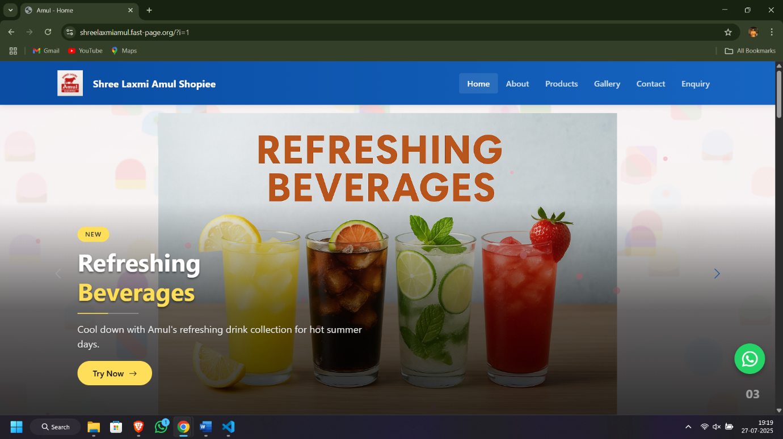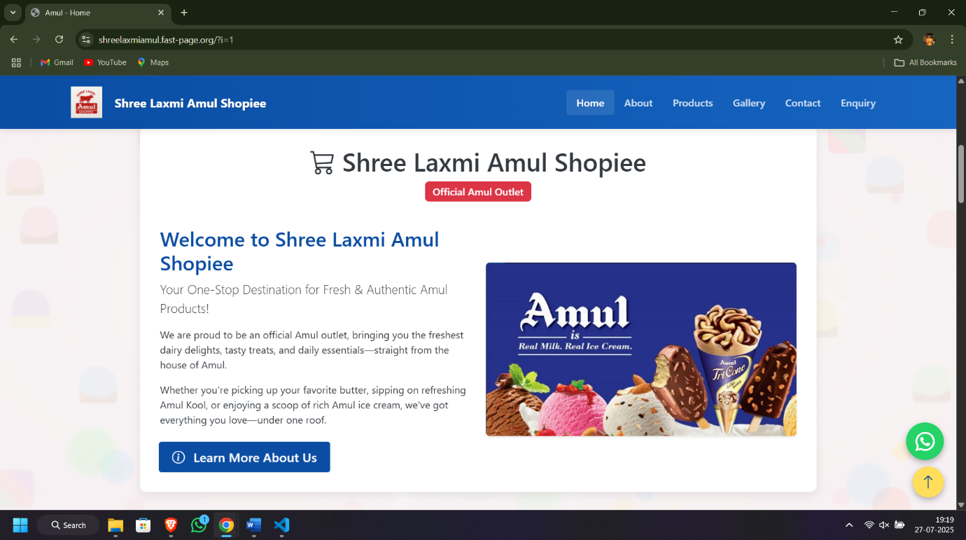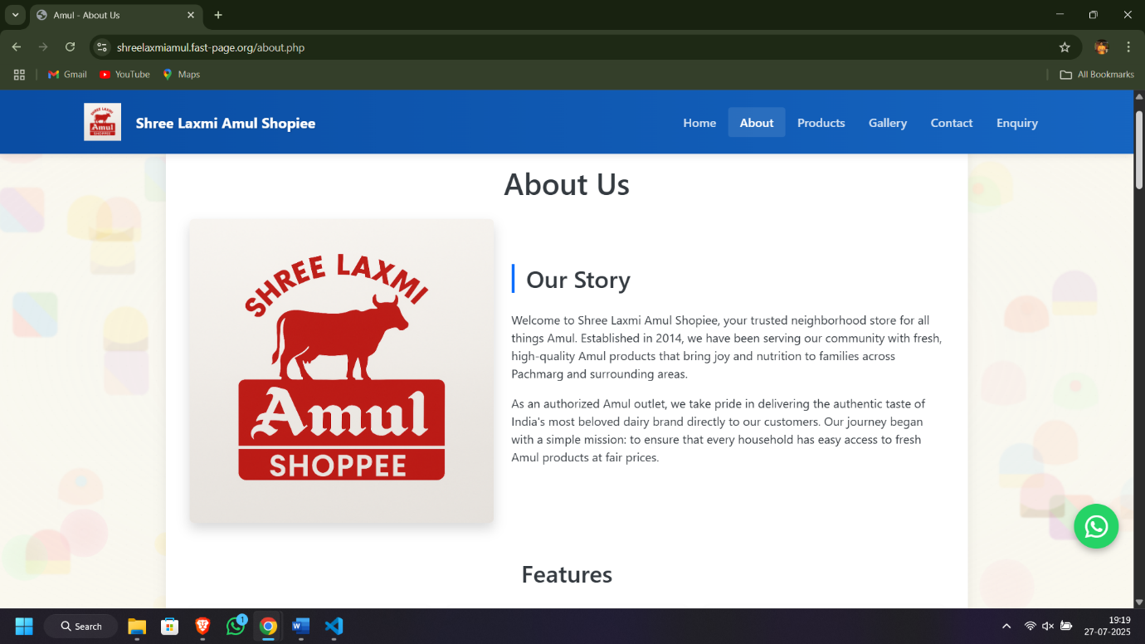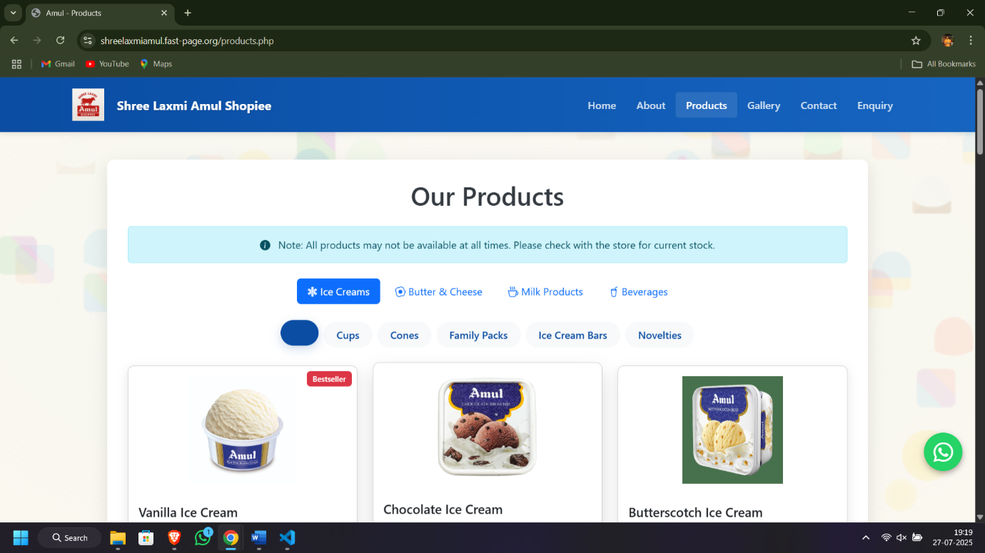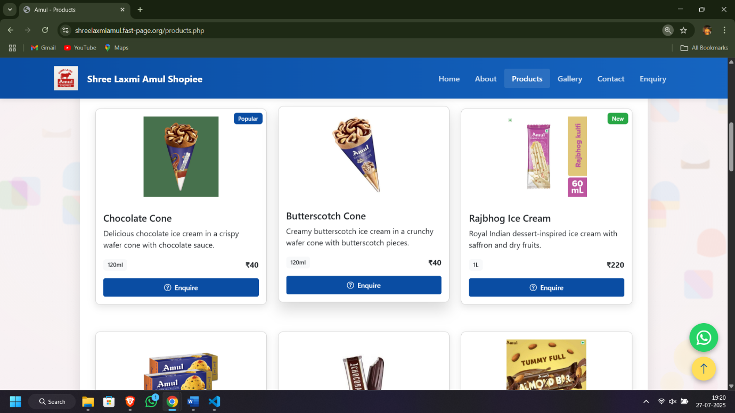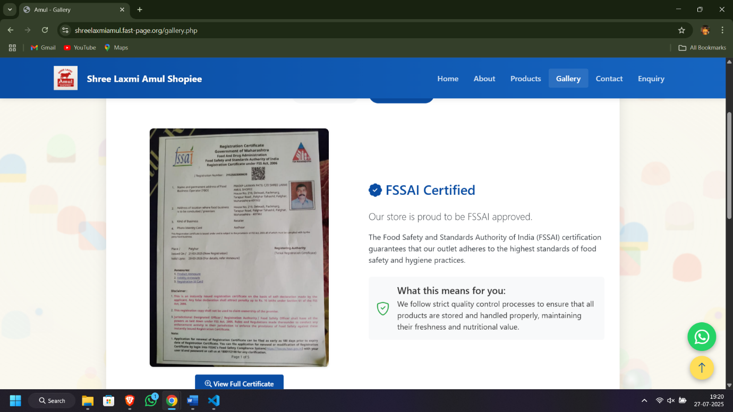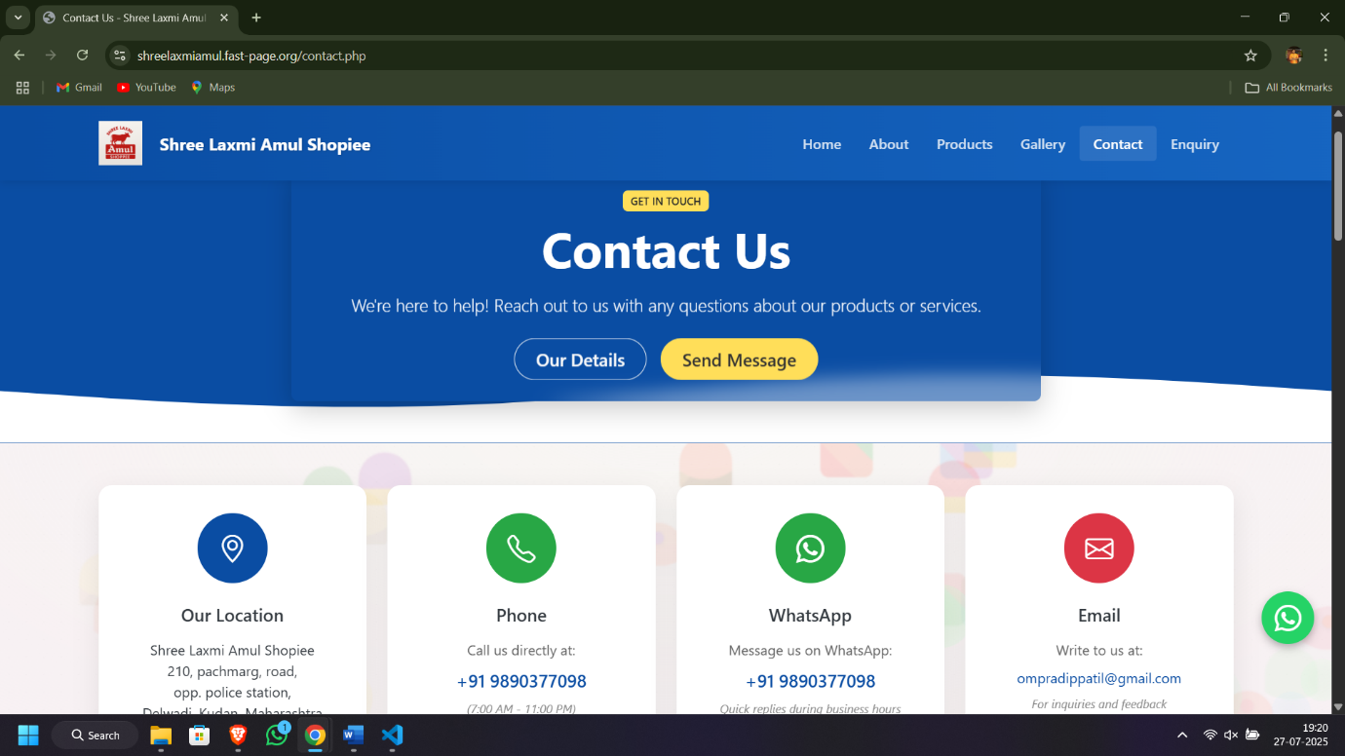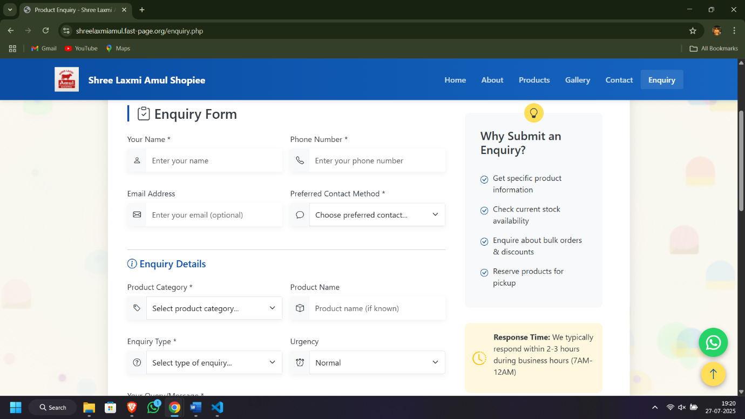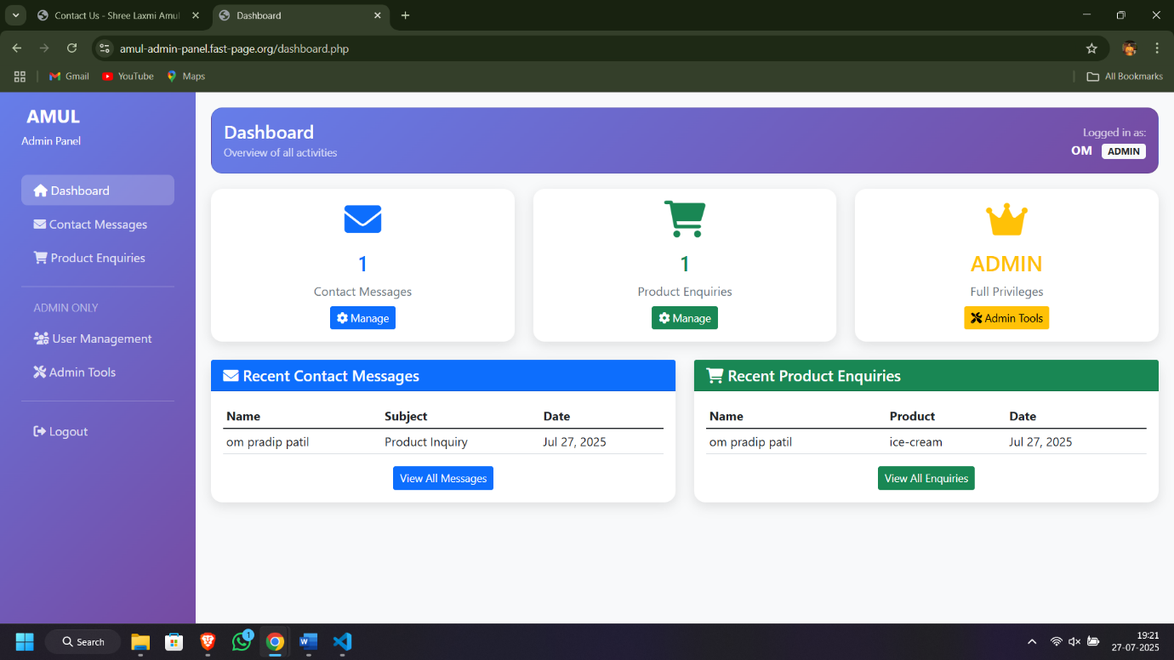

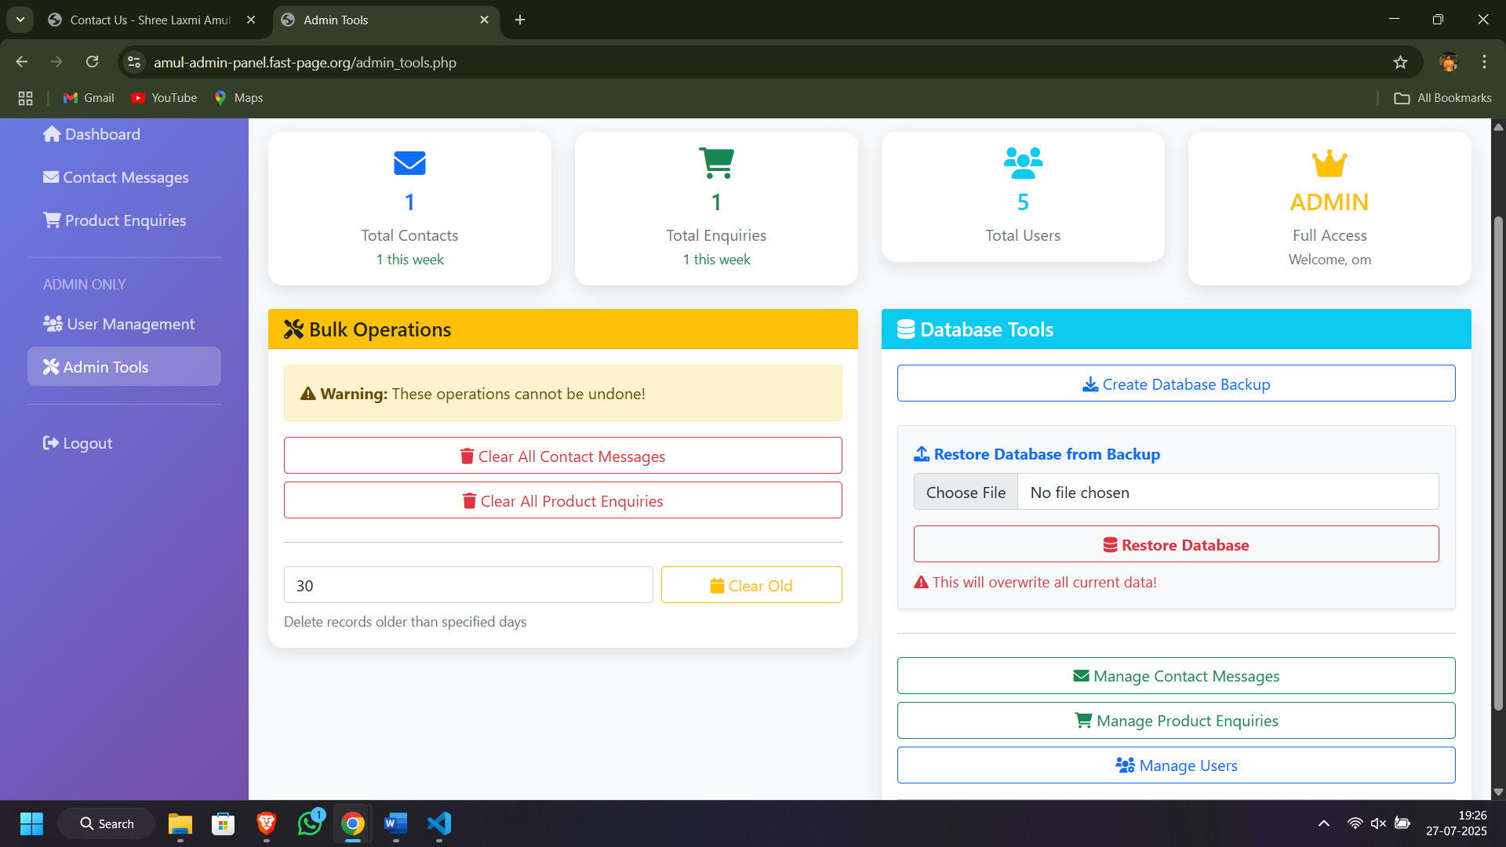

**Conclusion**

**My 12-week internship at CSISM Technologies** has been a transformative journey that significantly strengthened my skills in web development. Under the guidance of **Mr. Rohit Solanki** and the support of the development team, I gained hands-on experience with **HTML5, CSS3, JavaScript, PHP, and SQL**.

During this period, I successfully developed a **basic shop website** that included core functionalities such as product display, contact and enquiry forms, and responsive design. This project helped me understand both **frontend and backend development** processes in depth, including **database integration**, form handling, and user interaction.

I worked extensively with **Visual Studio Code** for development and **XAMPP** for local server setup and testing. The project was later **hosted on ByteHost** with a custom **domain name**, allowing real-time access to the website online.

This internship not only improved my technical skills but also boosted my confidence in problem-solving, debugging, and handling real-time deployment tasks. The mentorship, feedback, and exposure I received throughout were incredibly valuable and have left a lasting impact on my career journey.

I am thankful for this opportunity and excited to apply this practical knowledge to future web development projects.

**Certification**

